Assignment 1
Name: Bhye Muzaffar Alii Rohomuthally
Student number: 7871794

Program_1:

MOVZ x1, #1
MOVZ x2, #2
SUB x0, x1, x2
ADD x3, x0, x2

MOVZ x27, #0x1
LSL x27, x27, #28
STURW x3, [x27, #5]
LDURSW x4, [x27, #5]
MOVZ x5, #2
SUB x6, x5, x2
CBZ x6, label1
MOVZ x23, #28
label1: ADDI x0, x0, #2
MOVZ x26, #1
ANDS x26, x0, x26

CPU before execution: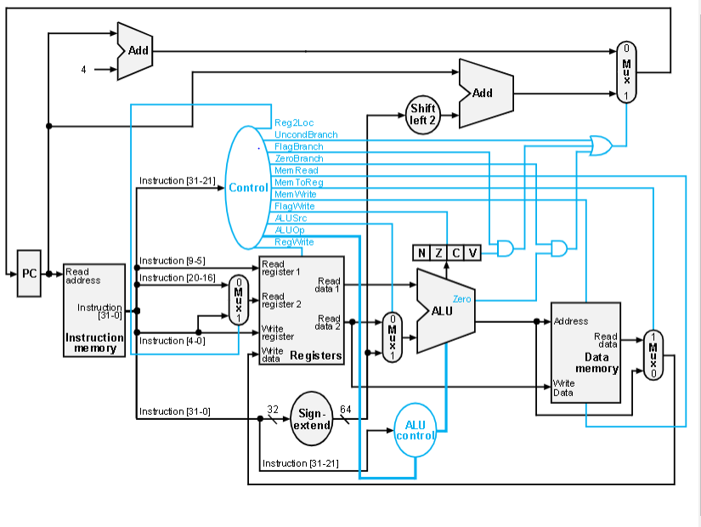

Instruction : MOVZ x1, #1
Before value(HEX): 0x0
After value(HEX) 0x1
CPU after instruction:
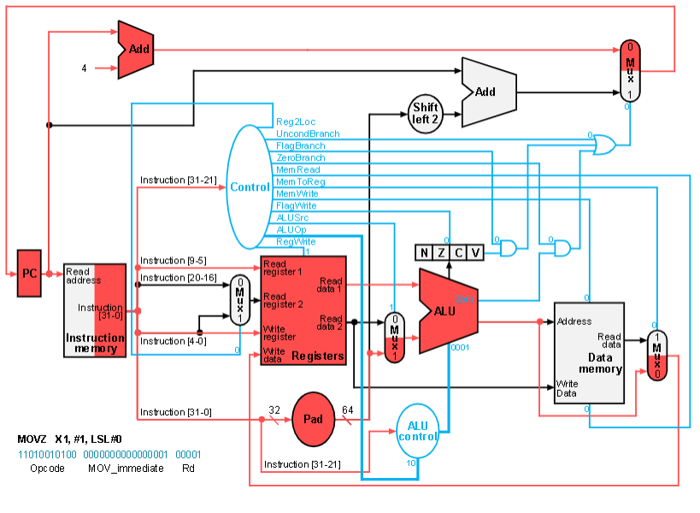

Instruction : MOVZ x2, #2
Before value(HEX): 0x0
After value(HEX) 0x2
CPU after instruction:
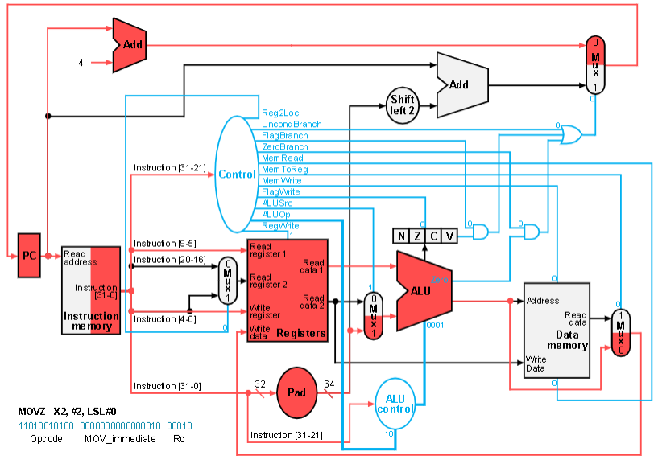

Instruction : SUB x0, x1, x2
Before value(HEX): 0x0
After value(HEX) 0xffffffffffffffff
CPU after instruction:
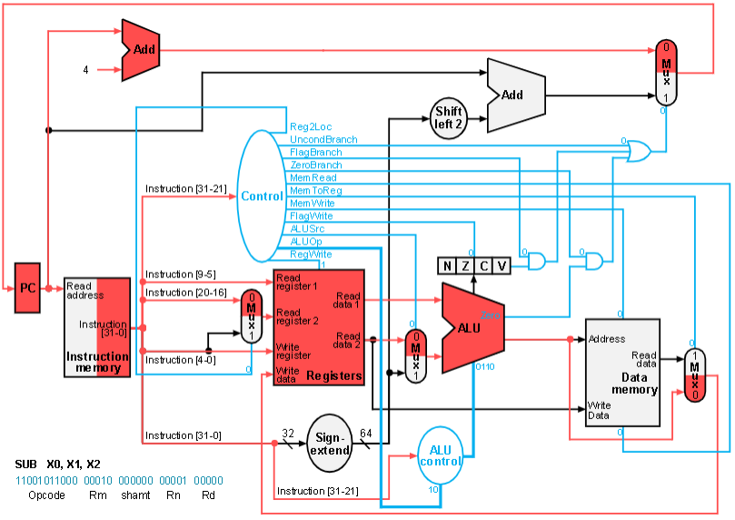

Instruction : ADD x3, x0, x2
Before value(HEX): 0x0
After value(HEX) 0x1
CPU after instruction:
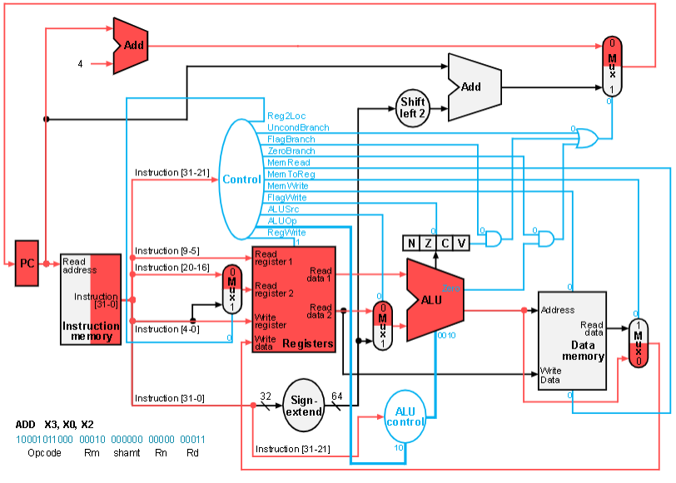

Instruction : MOVZ x27, #0x1
Before value(HEX): 0x0
After value(HEX) 0x1
CPU after instruction:
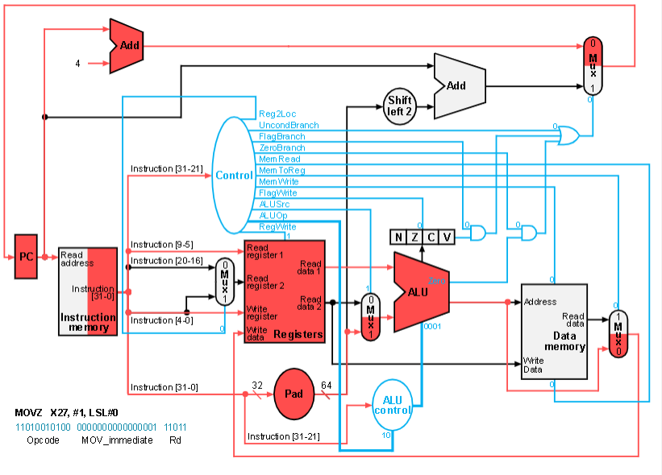

Instruction : LSL x27, x27, #28
Before value(HEX): 0x1
After value(HEX) 0x10000000
CPU after instruction:
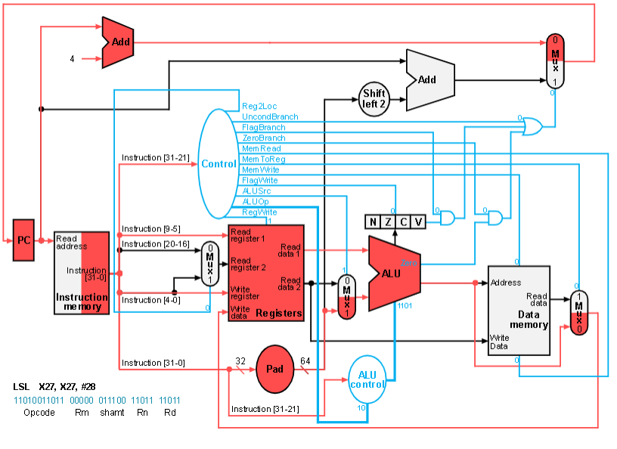

Instruction : STURW x3, [x27, #5]
Before value(HEX): Do not know value
After value(HEX) memory value of x32 becomes 0x1
CPU after instruction: 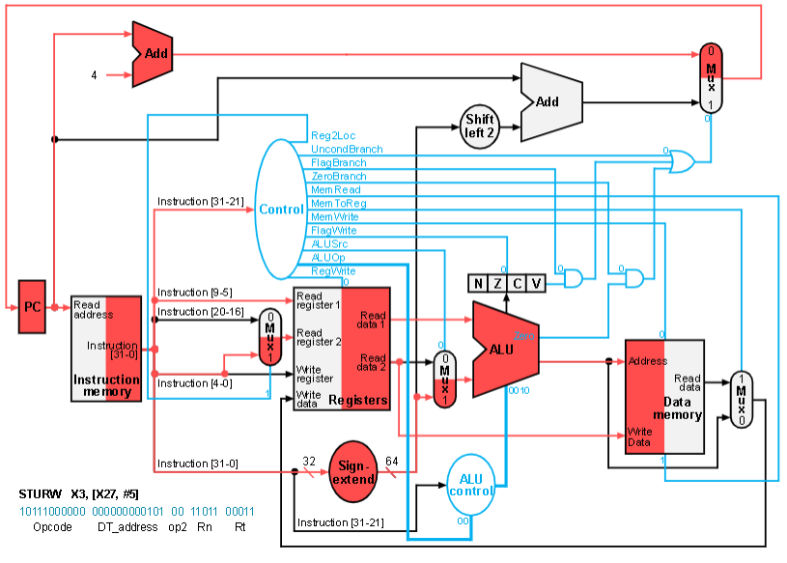

Instruction : LDURSW x4, [x27, #5]
Before value(HEX) register x4: 0x0
After value(HEX) 0x1
CPU after instruction:
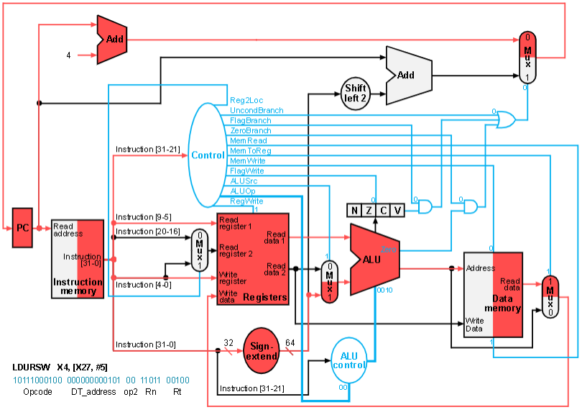

Instruction : MOVZ x5, #2
Before value(HEX): 0x0
After value(HEX) 0x2
CPU after instruction:
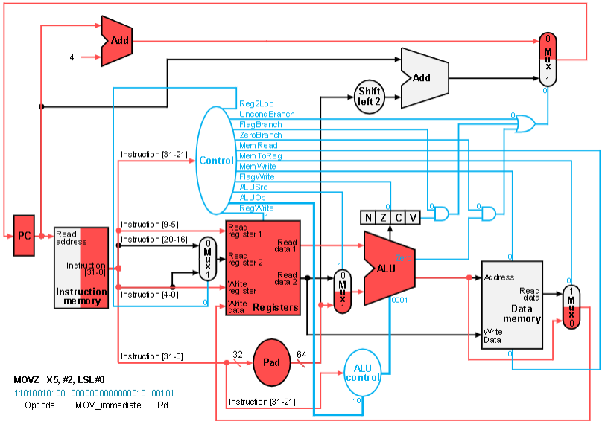

Instruction : CBZ x6, label1
Before value(HEX): N/A
After value(HEX) N/A
CPU after instruction:
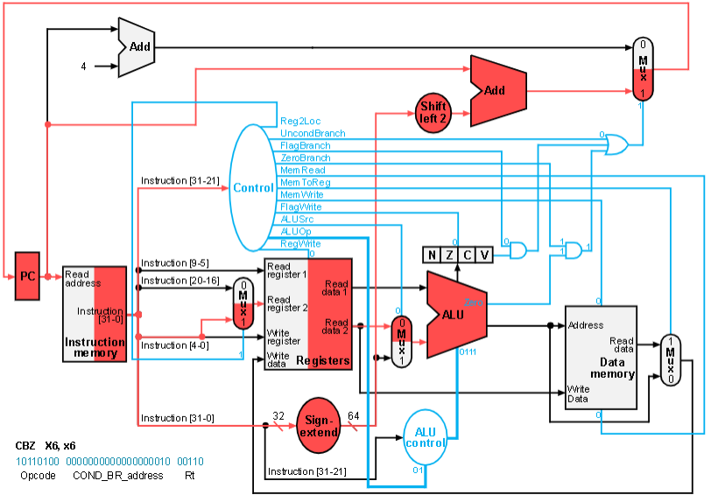

Instruction : label1: ADDI x0, x0, #2
Before value(HEX): 0xffffffffffffffff
After value(HEX) 0x1
CPU after instruction:
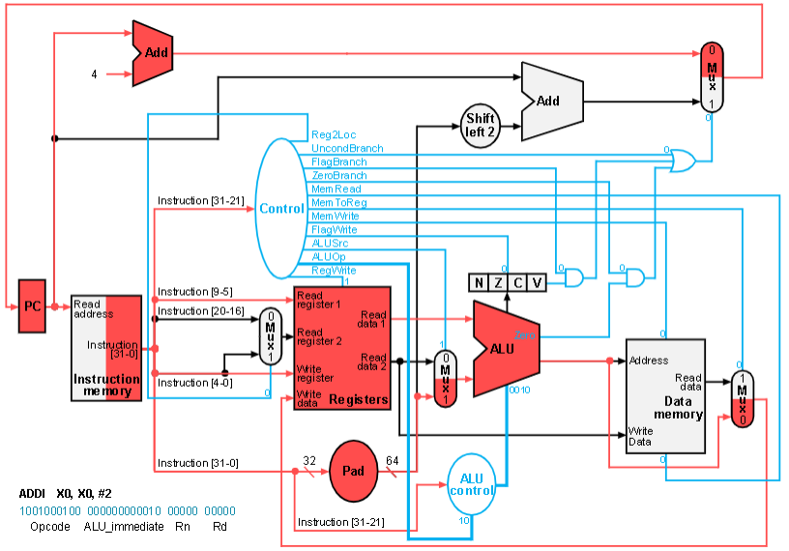

Instruction : MOVZ x26, #1
Before value(HEX): 0x0
After value(HEX) 0x1
CPU after instruction:
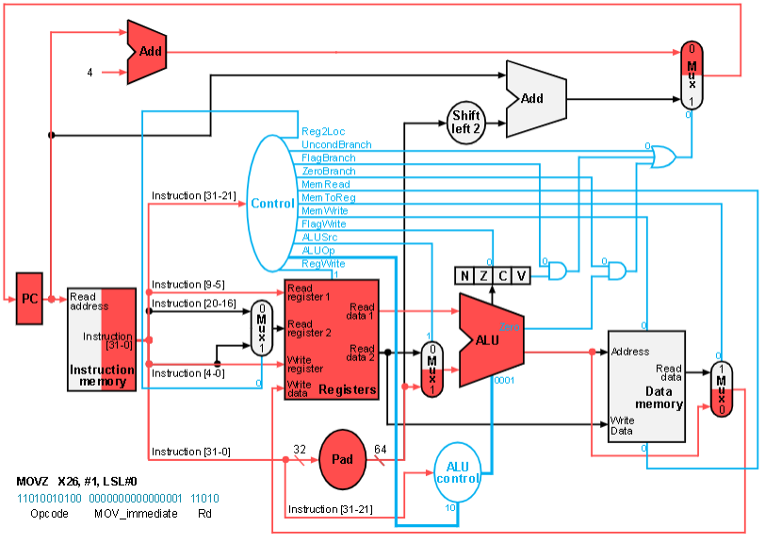

Instruction : ANDS x26, x0, x26
Before value(HEX): 0x1
After value(HEX) 0x1
CPU after instruction:
